The O’Schraves
(The O’Gorman-Schryer-Lefebvre Family Band)
A Great Canadian Musical Experience!

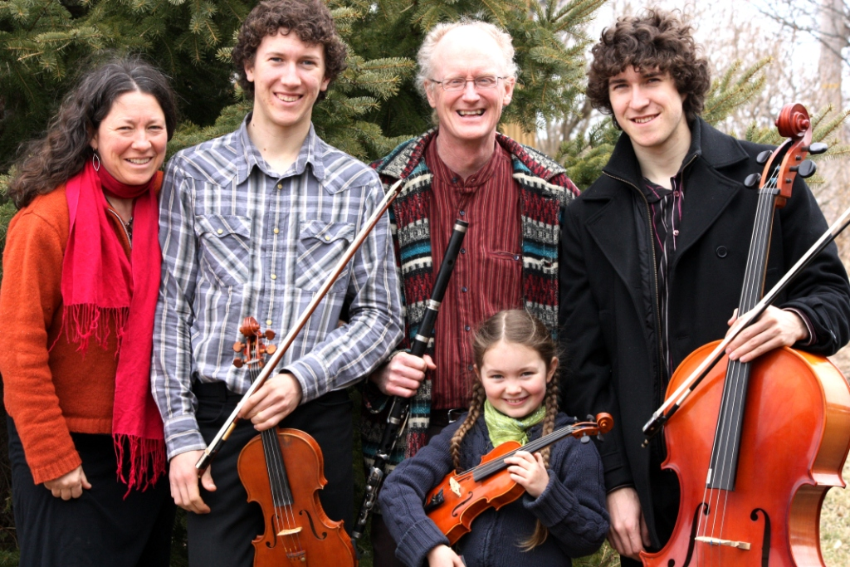
PATRICK O’GORMAN
IRISH FLUTE AND WHISTLES,
SCOTTISH AND IRISH PIPES

JULIE SCHRYER
piano

ZACH SCHRYER LEFEBVRE
CELLO, guitar, TIN WHISTLE, vocals

BENOIT SCHRYER LEFEBVRE
fIDDLE, TIN WHISTLE, BANJO, VOCALS

ÁINE SCHRYER O’GORMAN
FIDDLE, STEPDANCING, TIN WHISTLE

MYRIAM LEFEBVRE
STEPDANCING

SATURDAY, FEBRUARY 11, 8PM
BRUCE STATION COMMUNITY HALL
Adults $10, Ages 6-13 $5

SPONSORED BY
THE ROYAL CANADIAN LEGION LADIES AUXILIARY
BRANCH 211, BRUCE MINES

FOR MORE INFO, CONTACT CAROL WILSON 782-6764
REFRESHEMENTS WILL BE AVAILABLE

FUNDRAISER FOR LEGION BUILDING FUND AND COMMUNITY PROGRAMS

.

www.algomatrad.ca

